U.S. Alcohol Control Systems Revisited: An Update
Using Extended Series and Methods

Wagenaar, Harwood, Erickson, Dunsmuir
University of Minnesota
University of New South Wales

U.S. Alcohol Control Systems Revisited: An Update
Using Extended Series and Methods
A recently published review of the alcohol policy literature (Her, Giesbrecht, Room & Rehm, 1999) identified two dominant but divergent conclusions regarding the effects on alcohol sales and consumption attributable to changes in systems for controlling alcohol distribution at the retail level from state monopoly to private licensing. Since 1970 there have been eleven distinct distribution system changes implemented in seven states in the United States, the latest occurring in West Virginia when retail spirits (a.k.a. hard liquor) sales were privatized effective February 28, 1990. The goal of this study is to replicate and extend prior studies that assessed the consequences on alcohol consumption and sales of privatizing retail sales. Based on published critiques of the prior research, we re-ran and modified previously tested time series models. In addition, we applied the latest technical advances in pooled time-series cross-section model estimation methods. We begin with a brief history of the privatization of alcohol distribution at the retail sales level and review the research debates regarding the effects of these system changes on alcoholic beverage consumption.
After repeal of the 18th Amendment to the U.S. Constitution prohibiting the manufacture and sales of alcoholic beverages, 16 states retained direct control over the retail sales and distribution of wine and/or spirits, and some strong beers through monopoly systems. States gradually began to move retail distribution of alcohol to the private sector while maintaining some controls through licensing of these outlets. To date, only Pennsylvania and Utah continue their monopoly hold on the retail sales of both wine and spirits, while eleven states control the retail distribution of spirits alone—Idaho, Maine, Michigan, Montana, New Hampshire, North Carolina, Ohio, Oregon, Vermont, Virginia and Washington. Since 1968, Idaho, Maine, Montana, and New Hampshire shifted retail distribution of wines from monopoly/state control to the private sector and Alabama, Iowa and West Virginia privatized the retail sales of both wines and spirits. These seven states provide classic natural experiments for testing the effects of dramatic changes in social institutions from state to private control of the retail distribution of wine and spirits.
Focusing on one of these states—Iowa—and using time series models, Mulford, Ledolter and Fitzgerald (1988) found initial but no long lasting effects on wine and spirits sales (as a proxy for consumption) from shifts in the distribution system from state control to private licensing for the retail sale of both wine (in 1985) and spirits (in 1987). Holder and Wagenaar (1990) and Wagenaar and Holder (1991) disagreed with these findings, instead concluding from their analyses that these shifts substantially increased wine and spirits sales in Iowa at the time of the system shift and, they contend, resulted in a permanent overall sales increase even after initial spikes in sales. To determine whether these legal measures consistently produce increases in alcohol sales, Wagenaar and Holder (1995) examined five other states (Alabama, Idaho, Maine, Montana, and New Hampshire) that implemented similar shifts in systems controlling retail sales of wine and again found overall long-lasting increases. Through the 1990s, the two research groups debated this issue, strongly defending their findings and methods of achieving them (Wagenaar & Holder, 1991, 1993, 1996; Mulford, Ledolter, Fitzgerald, 1993; Mulford & Fitzgerald, 1996).
During these debates, a few other notable studies on monopoly-privatization shifts obtained mixed results regarding the effect on alcohol sales and consumption. Fitzgerald and Mulford (1992, 1993a, 1993b), using bivariate analyses, found no significant effects of privatization on individual, self-reported drinking and alcohol purchasing patterns in Iowa. Four other studies used pooled time-series cross-section methods to model alcohol sales across several states or the entire nation. Goel and Morey (1995) evaluated spirits sales in 42 states between 1959 and 1982 and found that sales were significantly lower in privatized systems (possible 48% lower?-ask DE). Hoadley, Fuchs and Holder (1984) examined spirits sales in 48 states over five-year intervals 1955-1980 and found higher alcohol sales in privatized states. McCormac and Filante (1984) found no significant effects of privatization on spirits consumption in all states and the District of Columbia between 1970 and 1975. Finally, Ornstein and Hanssens (1985) examined spirits sales across all states between 1974-1978 and found higher consumption levels in privatized states.
From these earlier studies, there is clearly no consensus on the effects on sales of privatizing the retail distribution of alcohol. Indeed, the reaction of Her and associates (1999) to the Wagenaar-Holder versus Mulford-Ledolter-Fitzgerald debate is that there remains many unanswered questions regarding the consequences of de-monopolization. These authors state that “overall, there are too few studies employing adequate statistical methodologies explicitly to explore the underlying causes of changing alcohol consumption and alcohol-related harm as a result of the privatization” (p.1135).
Our assessment of existing studies revealed limitations, in some cases, due to available data, especially the length of the series in question. For instance, the 1991 Wagenaar-Holder study assessed 228-months (1968-1987) of wine, beer and spirits sales in Iowa and West Virginia, beginning 150 months prior to the earliest system shift in 1981 (West Virginia wine) and ending just 9 months after the last change in March 1987 (Iowa spirits). The Holder-Wagenaar (1990) study extended the series to December 1989 for Iowa and bordering states, thus increasing their chances of finding significant long-term changes in sales. Mulford and colleagues (1992) used alcohol sales series covering January 1980 through May 1990 for their analysis of both wine and spirits sales trends in Iowa, resulting for wine in 66 months pre-intervention and 59 months post and, for spirits, 86 months pre-, 39 post-intervention. In addition to series length, some studies are limited by their use of annual data (Ornstein & Hanssens, 1985; Goel & Morey, 1995; ….check these and add others).
Debates among past researchers also point to disagreements about appropriate modeling of the series, in particular, decisions regarding differencing of the series under analyses and the inclusion of control series, for example national trends in sales. Furthermore, studies that used cross-sectional data relied on early statistical techniques that did not account for serial and auto correlations (for example, Hoadley, et al, 1984).
In this study, we replicate prior studies of the effects on alcohol sales of changing alcohol distributions systems from monopoly control to the licensing of private retail establishments. We use state-level monthly series of wine and spirits sales beginning 1968 through December 2000, a series length that improves the power to estimate both short- and long-term effects. We employ recent advancements in techniques for estimating pooled time-series cross- section regression models using monthly data (TSCSReg) adjusting correlation structures that violate regression assumptions. Furthermore, we test intervention effects using annual data across 32 years in OLS regression models with a pooled model.
Method
Design. Following the approach taken by Wagenaar and Holder (1991) and (1995), we treat the elimination of the state retail monopoly on wine and spirits as a natural experiment, using an interrupted time series design. The design involves an examination of observations over time that are hypothesised to be affected by the intervention and the utilisation of a comparison time series that was expected not to be affected. This design can be shown as:
X₁ X₂ X₃ … X_{n} I X_{n+1} X_{n+2} … X_{n+m}
X₁ X₂ X₃ … X_{n} X_{n+1} X_{n+2} … X_{n+m}
where X_{i} represents the sales of wine or spirits per month expressed as a volume of absolute ethanol, I represents the policy change ending a state monopoly, n is the number of observations before the end of the monopoly and m is the number of observations after the end of the monopoly. The second line in the design diagram above shows a comparison time series not influenced by the specific policy change being evaluated. In this study, the comparison or ‘control’ group consists of the states that did not implement any policy changes regarding the retail sales of alcohol.
Data. Outcome measures used are quantities of absolute ethanol sold in the form of wine measured as shipments from wholesalers to retail suppliers. While retail sales data for state monopoly stores is available before the end of wine monopolies, such data is not available from individual retail outlets after privatisation. Data on wholesale shipments, on the other hand, are consistently available throughout the thirty-year period studied. Consequently, our analysis focuses on wholesale data to provide a consistent measure of alcohol sales for the study period.
Data on monthly consumption of wine was obtained from January 1968 to December 1997 (n = 360) for the seven states that had adopted privatisation policy in wine sales at some point during the period. Source of wine data is the Wine Institute, based on reports from the Bureau of Alcohol, Tobacco and Firearms, U.S. Department of the Treasury. Wine ethanol figures were also adjusted beginning in 1984 to take into account the growing market share of wine coolers, which have lower alcohol concentration than other wine. Figure 1 shows the time series plots of wine sales in ethanol litres for each state and the aggregate sales for the non-intervention states.
At the outset, the question of whether the data requires an appropriate transformation needs to be addressed. Because the data exhibits increasing seasonal variation with the level of the series, a log-transformation was used to ‘equalise’ variability and reduce heteroskedasticity. Time series data on the drinking-age population for each state is also readily available and was utilised in our analysis as another control measure. Consequently, the log of the population-adjusted sales per capita becomes the dependent variable we wish to analyse in our study. Likewise, the aggregate consumption in the non-intervention states, henceforth known as the control covariate, undergoes the same transformations. This predictor is used to control for national trends and fluctuations that could influence the behaviour of the series, independent of the change in public policy.
These transformed quantities provide three distinct advantages. Firstly, a per capita measure effectively controls for differences in population across states. Secondly, the use of the drinking age population instead of total population prevents those under 21 years of age to be factored in to our analysis since they are ‘non-drinkers’ according to the law. Although this fails to account for the problem of underage drinking, the intuition behind this transformation is still theoretically sound. Finally, the logarithm metric improves the interpretability of parameter estimates because of its affinity with percentage changes. Figure 3 displays the time series plots for the transformed wine data while Figure 4 shows the transformed spirits data.
Data for these analyses were structured into 1) time-series variables with 384 data points, reflecting monthly data over 32 years and 2) annualized variables. The monthly time series intervention variables were used to indicate the date a particular state’s policy took effect to change the off-sale retail distribution of a particular type of alcoholic beverage (wine or spirits) from state or monopoly control to private licensees. Intervention variables are coded “0” for each month in the series while the state’s system was monopoly controlled and “1” at the month of shifting to a privatized system and “1” for each month
Statistical analyses. Box-Jenkins intervention-analysis models consistent with the Wagenaar and Holder approach were developed for each dependent time series variable using the SAS software package. As most statistical results in time series analysis are conditional on stationarity of the fundamental processes, the properties of each series are first considered, particularly the need for differencing transformations. Since monthly sales of alcoholic beverages are characterised by dominant seasonal cycles and serial correlation, multiplicative seasonal ARIMA models were developed iteratively for each series. The procedure involves repeatedly going through cycles of specifying a model, estimating it and evaluating its adequacy in terms of accounting for all significant dimensions of the autocorrelation structure in the time series. The general seasonal ARIMA model for the outcome variable y_{t} is given by:
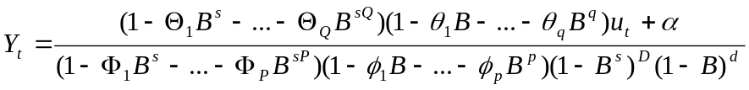 (1)
where p is the order of the autoregressive process, d is the degree of non-seasonal differencing, q is the order of the moving average process, P is the order of the seasonal autoregressive process, D is the degree of seasonal differencing, Q is the order of the seasonal moving average process, s is the seasonal span, 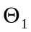 to 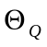 are seasonal moving average parameters, 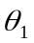 to 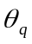 are regular moving average parameters, 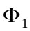 to 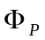 are seasonal autoregressive parameters, 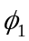 to 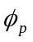are regular autoregressive parameters, u_{t} is a random white-noise error component, α is a constant and B is the backshift operator such that 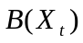equals 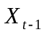.
In the present study, a preliminary ARIMA (p,d,q)(P,D,Q)_{s} model was identified for each series resulting from several iterations of the identification-estimation-diagnosis process. This model-building process ensures that all conventional criteria for ARIMA model adequacy are met, including statistically significant model parameters and the absence of serial correlation in the residuals.
Transfer functions representing hypothesised effects of the intervention were also added to the ARIMA model. The need to measure two specific effects of privatisation determined the functional form of these intervention components. While a step function is used to estimate the long-run or permanent change in the mean level associated with privatisation, a pulse function is used to control for transitory initial stocking effects. These temporary stocking effects represent the expected immediate surge in wholesale distribution as new private outlets throughout each state were stocked. The general form of the transfer function is given by:
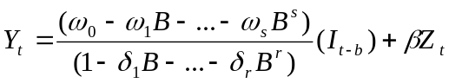 (2)
where 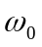 to 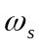 and 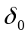 to 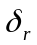 specify the manner in which the input or intervention variable, 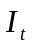, influences the output or dependent variable y_{t} . To test for effects of the intervention, is either a step function with the value zero before the intervention and one thereafter, or a pulse function with the value one for the month in which the intervention begins and zero otherwise; b is a delay parameter indicating the lag between the intervention and the initial effects of the intervention, Z_{t} is the control covariate while is its parameter coefficient. In the present case there was only one covariate, that being alcohol sales from non-intervention states, used to control for national trends and fluctuations when assessing intervention effects. The functional form of the step function, S_{t}, and the pulse function, P_{t}, are expressed as follows:
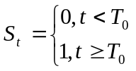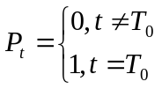
Long-term or permanent effects of privatisation, represented by S_{t}, were best modelled using the formula 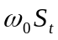, while temporary stocking effects were effectively captured by the expression 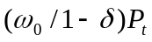. All parameters of each model, including the ARIMA components, step and pulse functions and the control variable, were then estimated simultaneously using maximum likelihood methods by combining Equations (1) and (2). However, it is important to note that the results obtained from the ARIMA models estimated in SAS are merely points of reference for future analysis to be performed in an alternative statistical package, S-Plus. Due to certain limitations of the SAS software, it was found necessary to replicate the intervention analysis described above in the S-Plus environment in order to proceed to the next stage of our investigation.
Researchers examining intervention effects are interested in accurately determining if an intervention is associated with a deviation from the expected path of a series. Accurate estimates of the variance structure are important for inference about such deviations. These reasons underscore the value of modelling approaches that can uncover changes in volatility following an intervention. The main technical innovation in this study is the use of a GARCH model to track changes in volatility after privatisation. It is conjectured that GARCH intervention models utilise full information in comparison to standard intervention models and thus provide a more rigorous framework for evaluating the impact of privatisation on alcohol consumption.
GARCH models were originally proposed to model financial time series. It is observed in many financial time series that although the residuals obtained after modelling the mean process are uncorrelated, the squared residuals are highly correlated. This implies that the variance of the time series is dependent on past observations. To capture this phenomenon of ‘clustering volatility’ Engle (1982) developed a new class of stochastic processes called autoregressive conditional heteroskedasticity (ARCH). These are zero mean, serially uncorrelated processes with non-constant variances conditional on the past, but constant unconditional variances. For such processes the recent past offers information about the one-period ahead forecast of volatility. The ARCH model was extended to the generalised autoregressive conditional heteroskedastic (GARCH) model by Bollerslev (1986) to allow the current conditional variance to be a function of past conditional variances as well as the past error terms derived from the mean process. The development of GARCH models not only facilitated effective modelling of the mean process, but more importantly, the time-dependent nature of volatility.
A GARCH intervention model that allows for ‘volatility effects’ is simply an ARIMA intervention model with the addition of a variance equation. In other words, the intervention model retains its mean equation through the combination of Equations (1) and (2), but is augmented by a conditional variance equation characterised by a GARCH process of orders m and n, denoted GARCH(m,n). A GARCH(m,n) model can be expressed as follows:
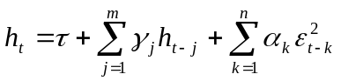 and 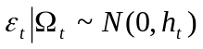 (3)
where 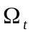 is the information set at time t on which the distribution of the errors is assumed to be conditioned, and τ, α and γ are parameters to be estimated. These parameters are also assumed to satisfy the following conditions: 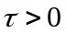, 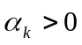 for 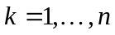 and 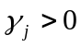 for 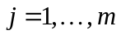. Equation 3 implies that conditional variances h_{t} at time t depend on recent squared innovations 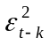 as well as on past conditional variances h_{t-j}. However, it might be expected that other exogenous variables such as the control covariate or the two transfer functions, could possibly influence the behaviour of the conditional variance. The decision to include these exogenous variables in the conditional variance equation is based on a stepwise examination of each variable’s contribution to improving model performance.
To determine the appropriate orders of ARCH and GARCH terms, m and n, respectively, we begin by estimating a simple GARCH (1,1) model. Higher order models are also estimated and compared to the GARCH (1,1) specification. Using standard model selection criteria such as the Akaike Information Criteria (AIC) and the Bayesian Information Criteria (BIC), as well as other diagnostic checks to be discussed later, the optimal GARCH (m,n) model is chosen among a variety of different specifications. These GARCH intervention models are estimated using the iterative BHHH algorithm, a non-linear optimisation technique in the S-Plus FinMetrics module used to compute maximum likelihood estimates (MLE). Convergence is reached within the specified maximum number of iterations (50) and reliable coefficient estimates and their corresponding standard errors are obtained.
Apart from checking the autocorrelation function plots for the absence of serial correlation, further diagnostic tests based on standardised residuals need to be performed in order to test the validity of the models. By defining the standardised residuals as follows:
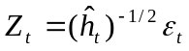 (4)
where 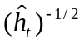 is the square root of the estimated conditional variance. If the GARCH model is correctly specified, then these standardised residuals and the corresponding squared standardised residuals should be uncorrelated. The Ljung-Box portmanteau test for serial correlation is used to assess the adequacy of these models. The Ljung-Box Q-statistic is given by:
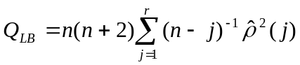 (5)
where 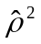 is the sample autocorrelation at lag j computed from the residuals and n is the number of observations. Under the null hypothesis that the model is correctly specified, Q_{LB} is asymptotically distributed as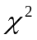 with 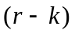 degrees of freedom, where k is the number of independent parameters.
To check the assumption of conditional normality of the residuals, an inspection of the quantile-quantile plots is carried out. The Shapiro-Wilk test however provides a more formal framework for determining the correct form for the density of 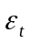. For further details of this normality test, refer to the S-Plus manual.
Results
- Case study for Iowa
  - Base Model and Results for Mean
  - Base Model and Results for Variance
  - Diagnostic Tests
  - Figure 2, Table 1
- Short Paragraph for each additional state
  - Table 1
  - Table 2

Figure 1 – Plots of Wine Consumption in 7 Intervention States and Aggregate of Nonintervention States

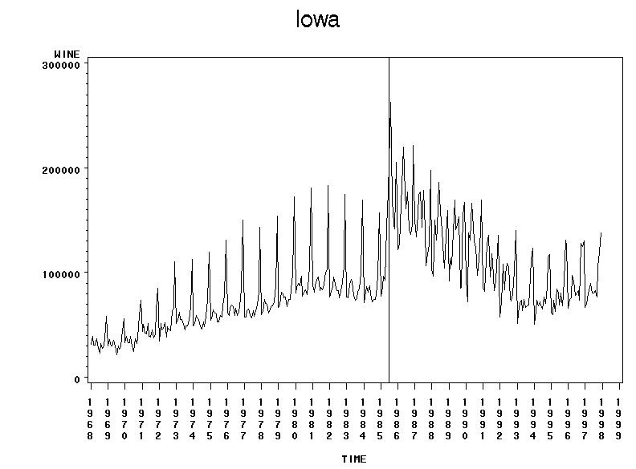
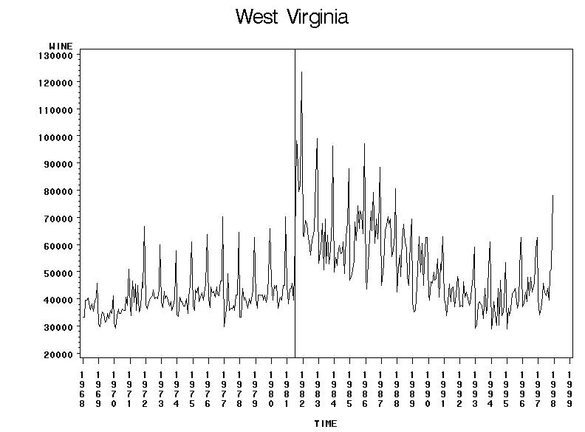

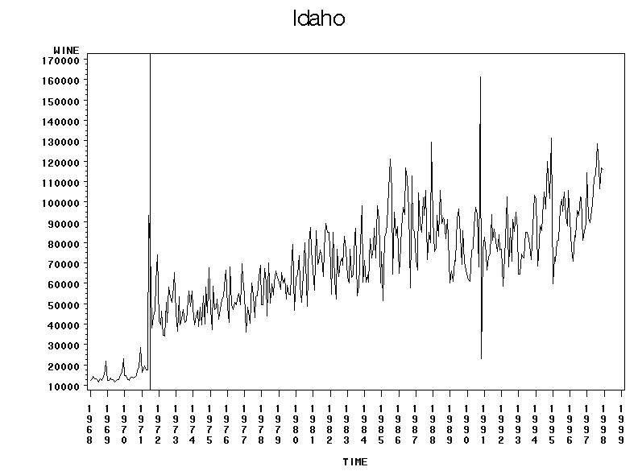
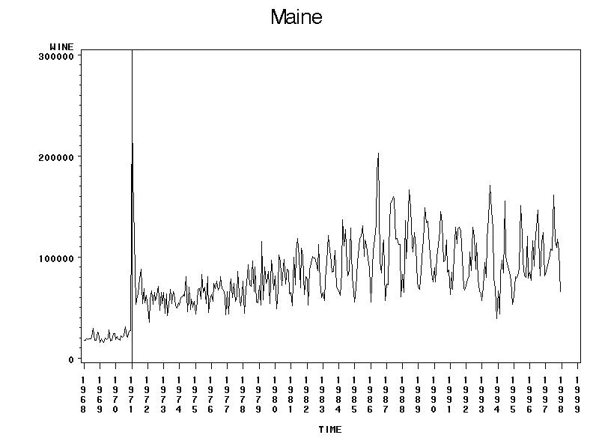
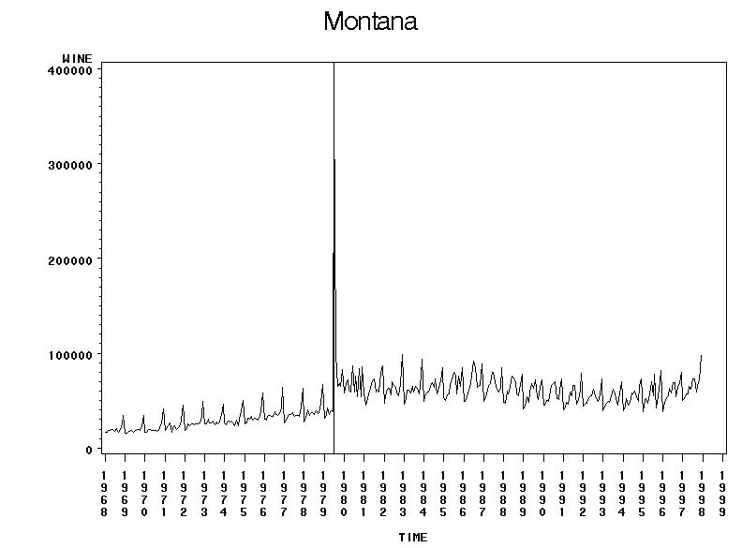
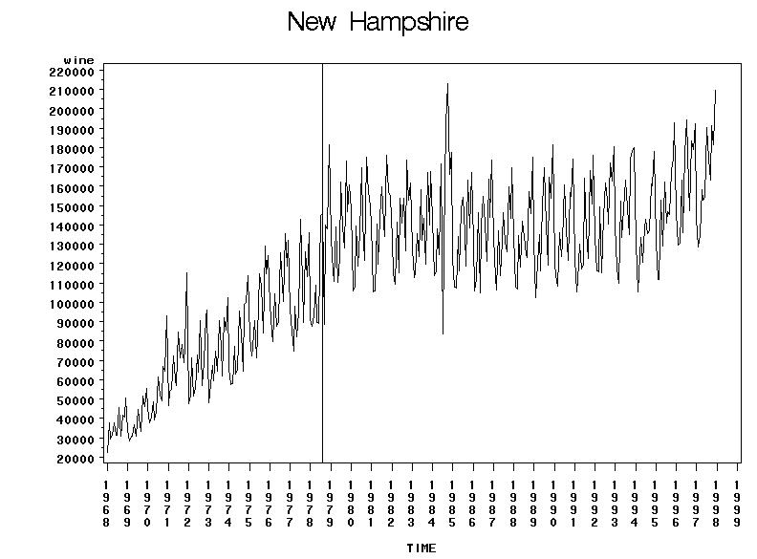
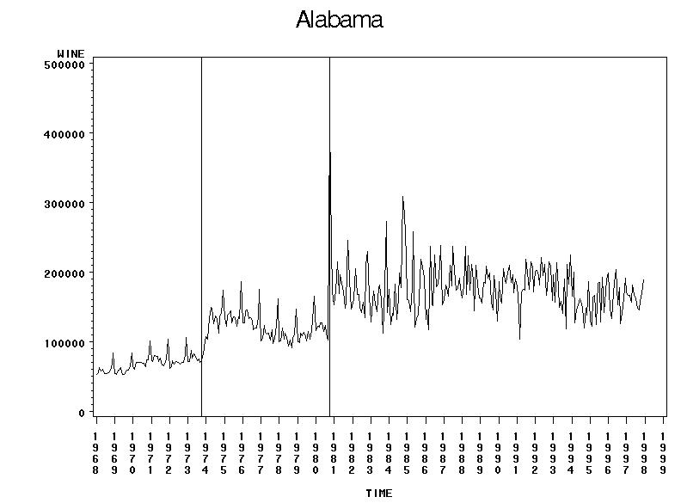
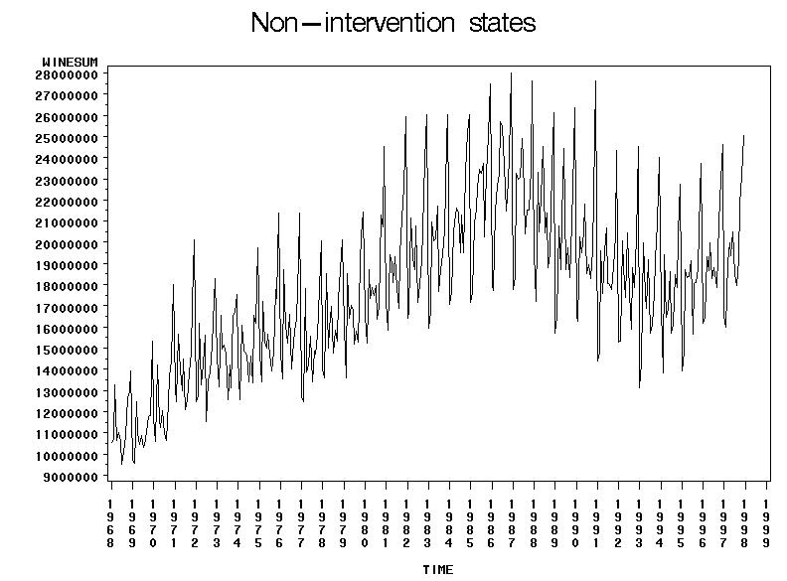
Figure 2 – Diagnostic Test Results for Iowa
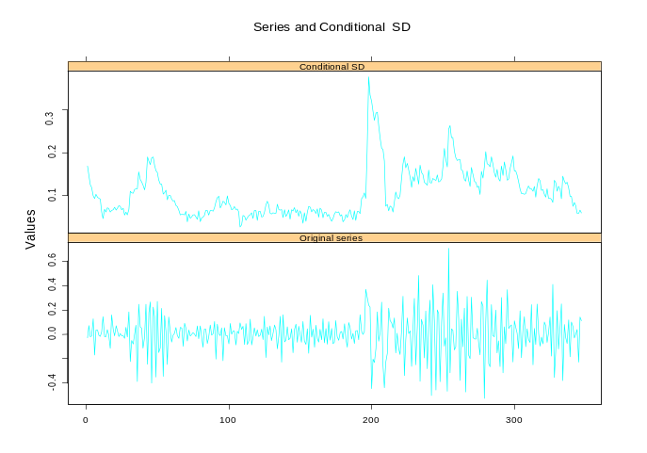
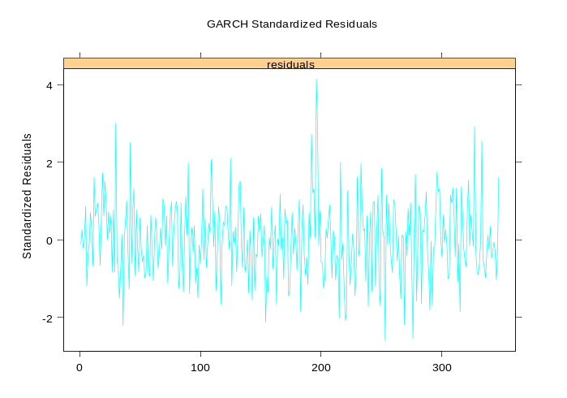
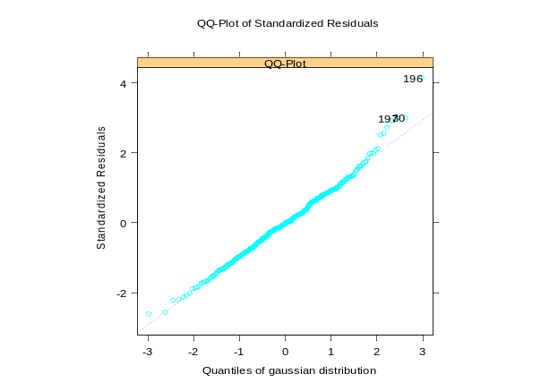
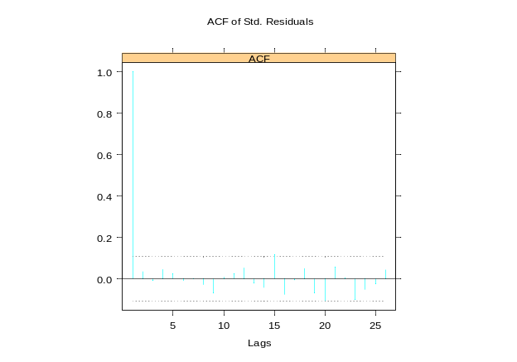
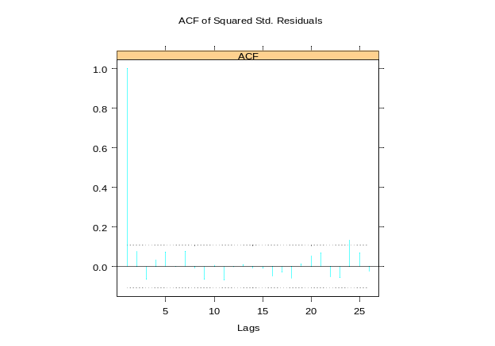

Table 1 – Effects of Privatization on Wine Sales: Results for both Mean Level and Variance Level for 7 States
 | Intervention Impact on Mean Level |  |  |  | Intervention Impact on Variance Level
State | Model | Input | Estimate(se) |  | Model | Input | Estimate(se)
Alabama | ARIMA(0,1,1)(0,1,1)₁₂ | 1973: Step (  Population  1980: Stock pulse (T1)  Step (T1) | .427(.03x)  .455(.076)  .762(.035)  .298(.038) |  | GARCH(x,x) | Step  Stepdown | .xx(.xx)  .xx(.xx)
Idaho | ARIMA(0,1,1)(0,1,1)₁₂ | Pulse  Decay  Step  Wine Control States | .890(.136)  .495(.104)  .830(.051)  .709(.101) |  | GARCH(0,0) | Step up at T0 | .0072(.0028)  .
Iowa | ARIMA(0,1,4)(0,1,1)₁₂ | Stocking Pulse (May ’85)  Stocking Pulse (June ’85)  Pulse  Decay  Step  Wine Control States | .150(.041)  .550(0.129)  .552(.106)  .665(.131)  .321(.124)  .354(.073) |  | GARCH(3,0) | Intervention  Stepdown | .0130(.0043)  -0.0088(.0048)
Maine | ARIMA(0,0,0)(0,1,1)₁₂ | Pulse  Decay  Step  Wine Control States | 1.738(.080)  .621(.?)  .849(.032)  .774(.118) |  | GARCH(1,1)
Montana | ARIMA(0,1,1)(0,1,1)₁₂ | Stocking Pulse  Pulse at T0+1  Decay  Step  Wine Control States | 1.870(.109)  .528(.164)  .306(.169)  .375(.026)  .690(.063) |  | GARCH(1,1)
New Hampshire | ARIMA(0,1,(1,2,3,4,12,13))  (0,1,0)₁₂ | Step  Population | .128(.036)  .226(.064)
West Virginia | ARIMA(0,1,3)(0,1,1)₁₂ | Pulse  Decay  Step  Population | .533(.091)  .745(.073)  .344(.074)  .575(.060) |  | GARCH(1,1)

Table 2 – Percent Change in Sustained Mean and Variance Associated with Intervention
 | Percent Change in Mean |  |  | Percent Change in Variance
State | First Year | Sustained |  | First Year | Sustained
Alabama: 1973
Alabama: 1980
Idaho
Iowa
Maine
Montana
New Hampshire
West Virginia

